## Video Data:

Here I am using the same project that I have created for Image classification AutoML.

1. Project id: hw2p1-image

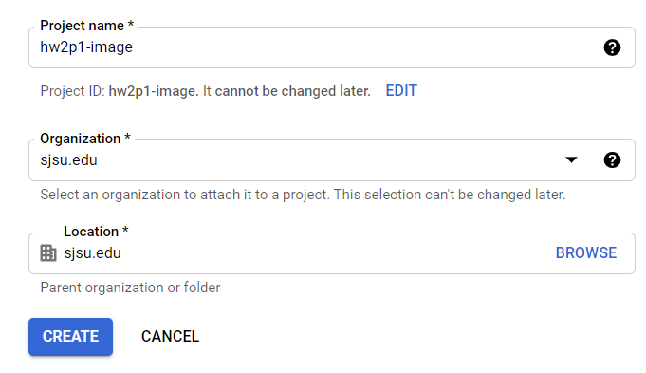

1. API is enabled

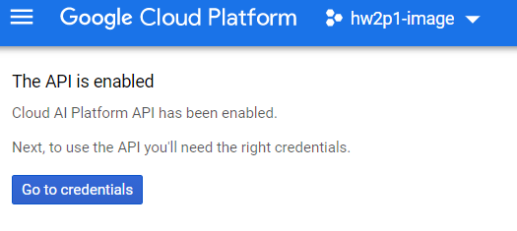

1. Authentication Setup

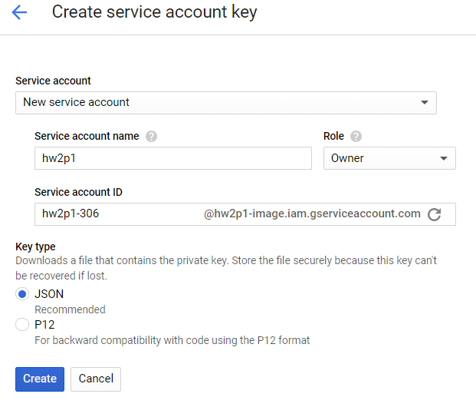

1. Set environment variable

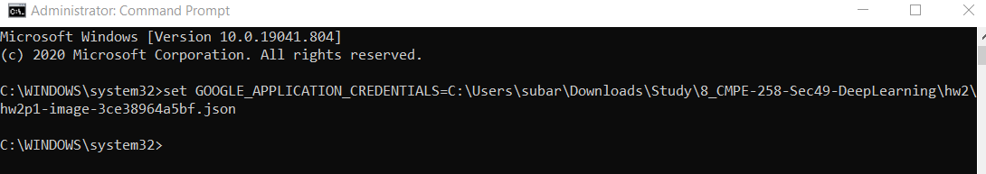

1. Cloud Console:

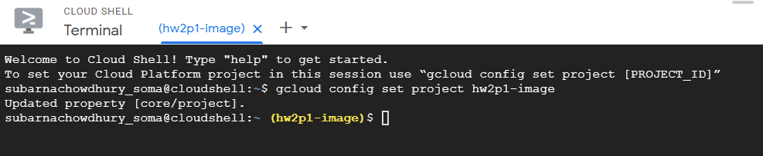

1. Create Dataset ‘hw2p1-video_classification’

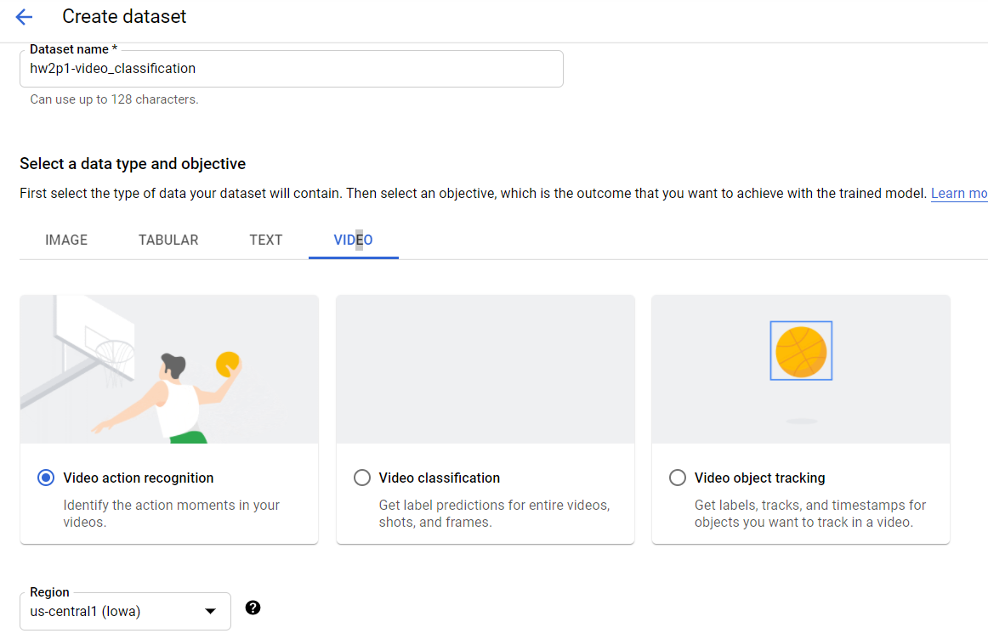

1. Import Data from Storage

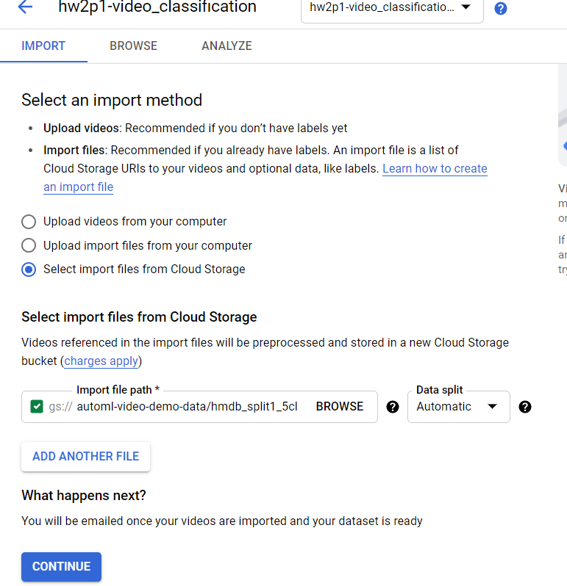

1. Finished Importing Data

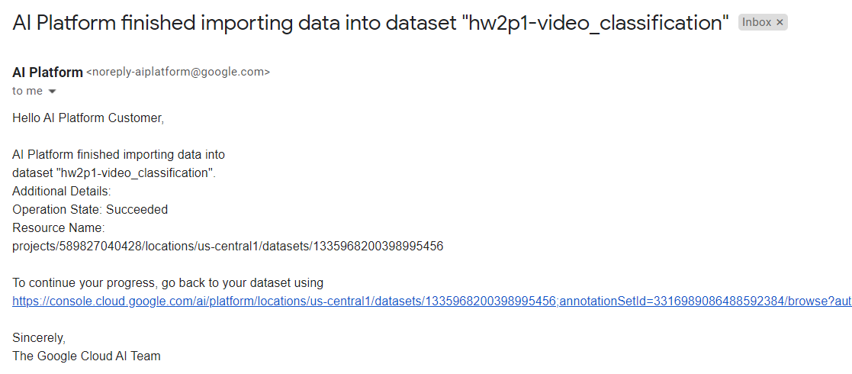

1. Created Training Model:

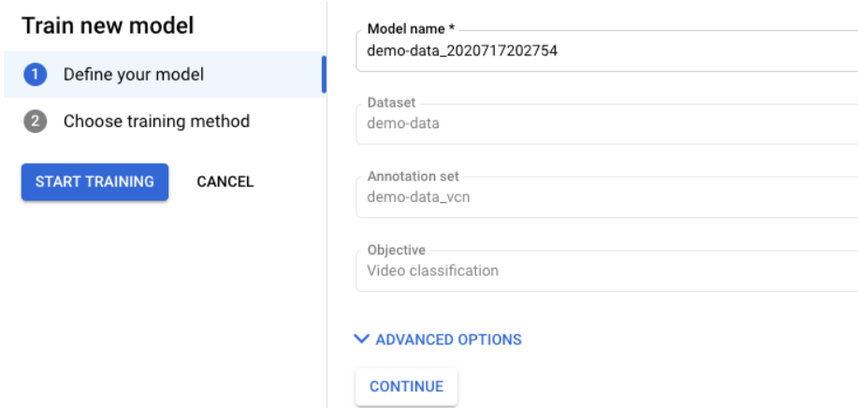

1. Got Email Notification about successful training

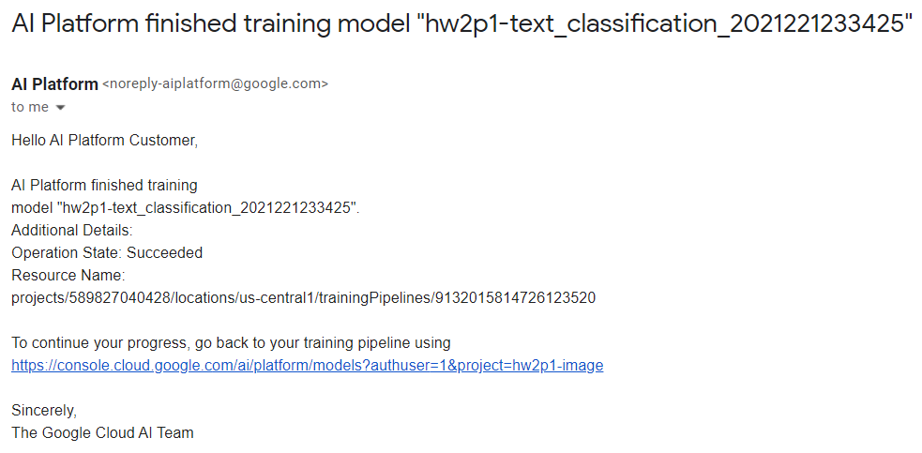

1. Evaluation

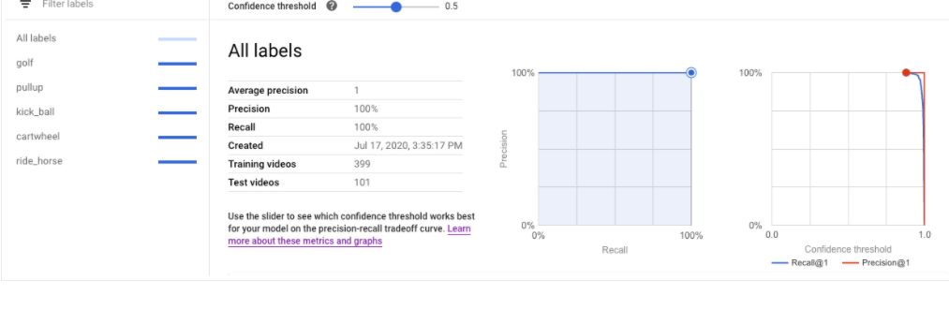

1. Batch Prediction Setup

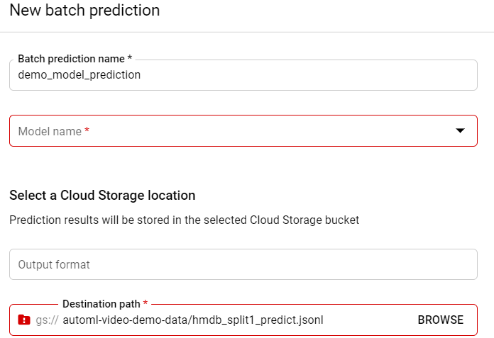

1. Prediction 100% Correct

